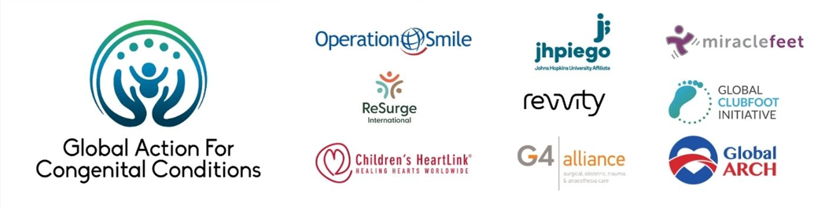Reaching SDG Child Mortality Targets through Collective Advocacy for Congenital Conditions

Lead Organization(s) and Country/Region

**Global Action for Congenital Conditions (GACC)** is a coalition that seeks to transform how health systems and communities provide lifelong care for individuals affected by congenital conditions, advocating for their survival, dignity, and quality of life.

GACC was founded by the following founding members: **Children’s HeartLink**, the **Global ARCH** (Global Alliance for Rheumatic and Congenital Hearts), the **G4** **Alliance** (Global Alliance for Surgical, Obstetric, Trauma and Anesthesia Care), **Jhpiego**, **MiracleFeet**, and **Operation Smile**. Additionally, GACC works with the **World Health Organization** as its multilateral partner.

Problem Statement

At WHA 77 Member States adopted a resolution responding to slowing progress in tackling maternal, newborn, and child mortality and for the first time called out congenital conditions as a key driver of childhood mortality that needed to be addressed.  With childhood mortality reduction efforts stagnating, now is a critical moment for NGOs, patient and family advocates and policy makers to unite and advocate for the investment and integration of congenital conditions into maternal and child health programs.

An estimated 8 million babies are born with a congenital condition each year, and an estimated 240,000 die worldwide in their first month of life, making congenital conditions a leading cause of both neonatal and post-neonatal deaths. Whether or not these children survive and grow to reach their full human potential depends largely on birth location and access to treatment throughout their lifetime. There is a dire need for more comprehensive treatment facilities and programs to prevent the deaths of these children, and to provide them with lifelong care.

Innovation or Practice Description

Despite the significant and growing impact of congenital conditions, communities, governments and policy makers continue to lack awareness of this issue, and global progress has been minimal. Ensuring lifelong care for all impacted by congenital conditions will require leadership and investment at the local, national, and global levels.

GACC’s global mission is to **transform how health systems and communities provide lifelong care for people affected by congenital conditions**, and its vision is **a world in which every person affected by congenital conditions survives, thrives, and lives with dignity**.

GACC works to address:

* The lack of prioritization of congenital conditions in national health agendas and global health policies.
* Insufficient awareness, attention, and investments in serving individuals born with congenital conditions, especially in low- and middle-income countries.
* The lack of unified action to address congenital conditions globally, resulting in fragmented and under-resourced initiatives.
* The need for collaboration across various conditions to improve lives and address the gaps in resources, programming, and attention for all with congenital conditions.

GACC offers a supportive community, empowering individuals and organizations to collaborate effectively. By fostering knowledge sharing and setting clear priorities, GACC enables a unified approach to addressing congenital conditions, amplifying the impact of collective efforts.

This coalition collaborates in three areas:

* Collective Advocacy
* Implementation and Knowledge Sharing
* Mobilizing support and funding

Results and Evidence of Impact

This is a brand new coalition and we are still starting our activities. So far we have organized three side events with an estimated attendance of 200 people, the third event is forthcoming on May 19th. We planned and organized a World Birth Defects webinar with over 100 people international attendance and we have participated in the WHO consultation on screening, diagnosis and lifelong management of birth defects. Collectively our organizations serve thousands of children born with and people living with congenital conditions, and have trained thousands of healthcare professionals. We are now coming together to advocate for sustained policy action from governments around the world.

Scalability & Sustainability

Yes! Advocacy and collaboration are always scalable! With this coalition, we are bringing together different conditions that all originate at birth and are creating a collective voice for all people and families affected by them. A global congenital conditions advocacy coalition is an adaptable strategy for diverse contexts, particularly where congenital conditions are under-recognized. Its flexibility and broad net allow for alignment with local health priorities and systems and advocating for policies such as national birth defect surveillance, integration into maternal and child health programs, and SDG commitments. We are especially proud of the strong inclusion we have of patient and family voices and the representation of patient advocates in all of GACC’s activities.

Lessons Learned, Key Insights

* Data drives action – we have seen firsthand that governments and multilateral organizations are taking notice of the epidemiological transition in causes of childhood mortality and increasing contribution of congenital conditions.
* Sustained funding is a challenge – Long-term investment is needed, not just short-term project-based support.
* Patient and family voices are powerful – Engaging families and individuals with lived experience strengthens advocacy and validates the work.
* Cross-sector collaboration is vital – Success depends on partnerships among governments, civil society, clinical community, researchers, private sector and affected patients and families.
* Individuals and families living with congenital conditions require lifelong, comprehensive care and support, that they are still not receiving and many conditions are still addressed with episodic care.